**Exercise 1 : Implementation of Singleton Pattern**

**Code** :

**Logic and Implementation Code For Singleton Pattern :**

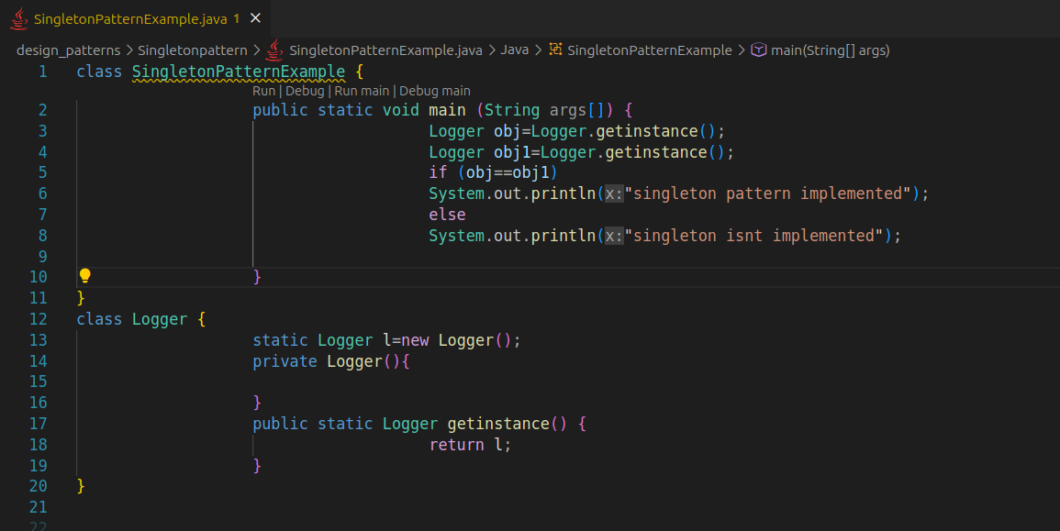

**Output** :

